p

**Year 9 - Summer Term**

**Literature: Dystopian Worlds**

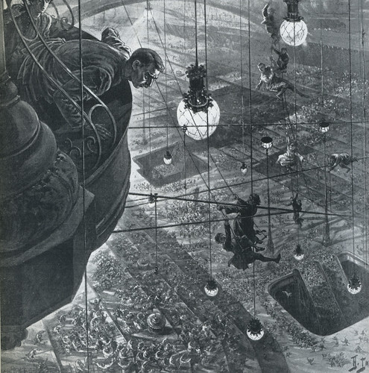

**Key Terms for this unit:**

* Utopia
* Dystopia
* Oppression
* Exposition
* Symbolism
* Dissent

**Homework**

* Students should select a book from the reading recommendations for this unit and read for at least one hour per week.

**Library Lessons and Accelerated Reader.**

Students have a reading lesson in the library once a fortnight with their English teacher. This is an opportunity to check they are reading the correct books, find out if there are any problems and encourage them to try something new. Students should complete a quiz on every book they read.

They can also quiz from home. They can access Accelerated Reader via the school website.

**Assessment for this unit:**

Writing a Dystopian short story.

Producing a guide to a created dystopic society (group project).

**What will we be looking at:**

Reading and writing skills for GCSE Lang & Lit

**D.E.A.R**

Students will stop what they are doing once a day and read for 20 minutes in lessons.

They must have a reading book with them every day.

**Reading Recommendations:**

**Oryx & Crake** by Margaret Atwood

**Station Eleven** by Emily St. John Mandel

**The Trial** by Franz Kafka

**Fahrenheit 451** by Ray Bradbury

**The Power** by Naomi Alderman

**Blindness** by Jose Saramago

**Never Let Me Go** by Kazuo Ishiguro

**Battle Royale** by Koushun Takami

**Eve of Man** by Giovanna & Tom Fletcher