p

**Year 9 - Spring Term**

**Literature: Gothic / Language: Paper 2**

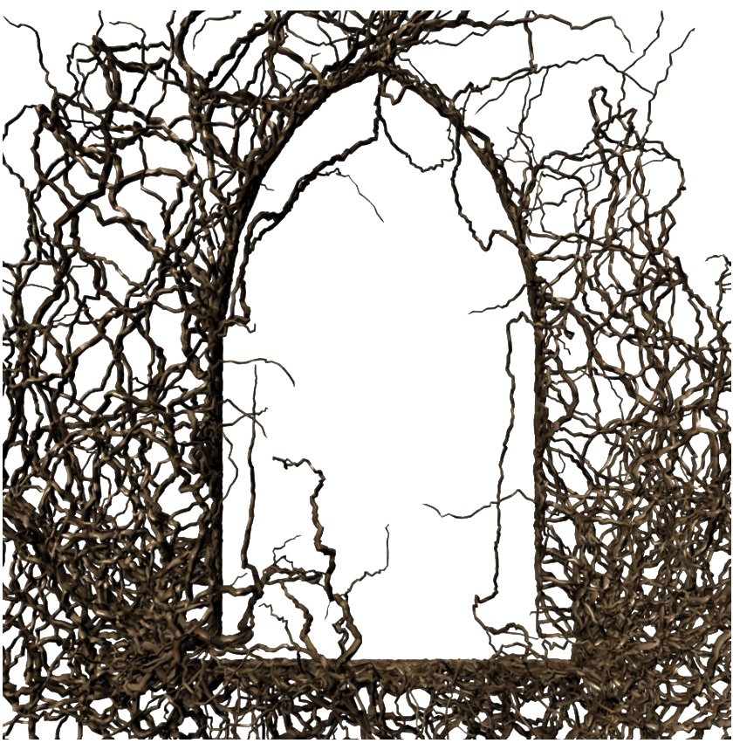

**Key Terms for this unit:**

* Gothic
* Gender
* Semantic field
* Peripeteia
* Foreshadowing
* Framed narrative

**Homework**

* Challenge Project - this is an ongoing project designed to expand understanding of the gothic and its main themes/ ideas. A selection of tasks is available for students to choose from for each assignment.

**Library Lessons and Accelerated Reader.**

Students have a reading lesson in the library once a fortnight with their English teacher. This is an opportunity to check they are reading the correct books, find out if there are any problems and encourage them to try something new. Students should complete a quiz on every book they read.

They can also quiz from home. They can access Accelerated Reader via the school website.

**Assessment for this unit:**

Writing a Gothic short story. We will do drafts and practice on this before the final assessment.

Language Paper 2 Year 9 exam will be sat at the beginning of the Summer Term.

**What will we be looking at:**

Ambitious vocabulary

Use of structural features

Descriptive writing

Writing for purpose (Gothic conventions)

**D.E.A.R**

Students will stop what they are doing once a day and read for 20 minutes in lessons.

They must have a reading book with them every day.

**Reading Recommendations:**

**The Birdcage** by Eve Chase

**The Talented Mr Ripley** by Patricia Highsmith

**Shakespeare on Toast** by Ben Crystal

**The Bloody Chamber** by Angela Carter

**Hamlet** by William Shakespeare

**Lore** by Alexandra Bracken

**The Song of Achilles** by Madeleine Miller