p

**Year 9 - Autumn Term**

**Shakespeare: Macbeth**

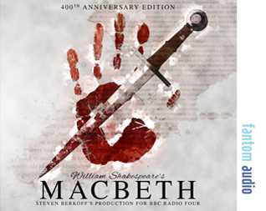

**Key Terms for this unit:**

* Context
* Author’s Purpose
* Supernatural
* Ambition
* Manipulation
* Tension

**Homework**

* GCSE Pod - this has many short videos and questions on the topics that we study whilst reading the text. These will be set on Google Classroom.

**Library Lessons and Accelerated Reader.**

Students have a reading lesson in the library once a fortnight with their English teacher. This is an opportunity to check they are reading the correct books, find out if there are any problems and encourage them to try something new. Students should complete a quiz on every book they read.

They can also quiz from home. They can access Accelerated Reader via the school website.

**Assessment for this unit:**

Macbeth essay on extract and whole text. This is in the form of a GCSE style question. We will do drafts and oracy practice on this before the final assessment.

**What will we be looking at:**

Reading the play

Analysis of language

Author’s purpose

Persuasive techniques

Wider context

Literature Paper 1 Skills

**D.E.A.R**

Students will stop what they are doing once a day and read for 20 minutes in lessons.

They must have a reading book with them every day.

**Reading Recommendations:**

**Shakespeare on Toast** by Ben Crystal

**King Lear** by William Shakespeare

**Oedipus Rex** by Sophocles

**Moby Dick** by Herman Melville

**The Sound and the Fury** by William Faulkner

**Hag-Seed** by Margaret Atwood