p

**Year 8 – Spring 1 Term**

**Poetry**

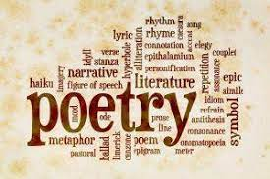

**Key Terms for this unit:**

* Caesura
* Enjambment
* Compare/contrast
* Extended metaphor

**Reading Recommendations:**

**That’s Left in the World** by Erik J

**Just Sayin’** by Malorie Blackman

**Toffee** by Sarah Crossan

**The Women Could Fly** by Megan Giddings

**How Not to be Strong** by Alex Scott

**Library Lessons and Accelerated Reader.**

Students have a reading lesson in the library once a fortnight with their English teacher. This is an opportunity to check they are reading the correct books, find out if there are any problems and encourage them to try something new. Students should complete a quiz on every book they read.

They can also quiz from home. They can access Accelerated Reader via the school website.

**Assessment for this unit:**

Analytical paragraphs. Students will be comparing the similarities and differences between 2 poems they have studied.

**What will we be looking at:**

* Comparison
* Analyse writers’ purpose
* Effect on reader
* Language & Structure

**D.E.A.R**

Students will stop what they are doing once a day and read for 20 minutes in lessons.

They must have a reading book with them every day.

**Homework**

**Wider reading topics:**

Lark by Anthony McGowan

The Jabberwocky by Lewis Carroll

The Sweet Shop by Roald Dahl

*Some of these will be set on Google Classroom – Students are expected to read them and then answer a few comprehension questions.*

**Students will also be set occasional spelling homework.**