p

**Homework**

**Wider reading topics:**

* The Ungrateful Refugee, Dina Mayeri
* Refugee Blues by W.H.Auden
* Opening of Fahrenheit 451 by Ray Bradbury
* Text of a speech Marie Colvin gave at St Bride's church, Fleet Street, London on November 10, 2010
* Extract from Journey’s End by R.C. Sheriff
* Extract from The Handmaid’s Tale by Margaret Atwood

*Some of these will be set on Google Classroom – students are expected to read them and then answer a few comprehension questions.*

**Students will also be set occasional spelling homework.**

**Year 8 - Autumn Term**

**Human Nature**

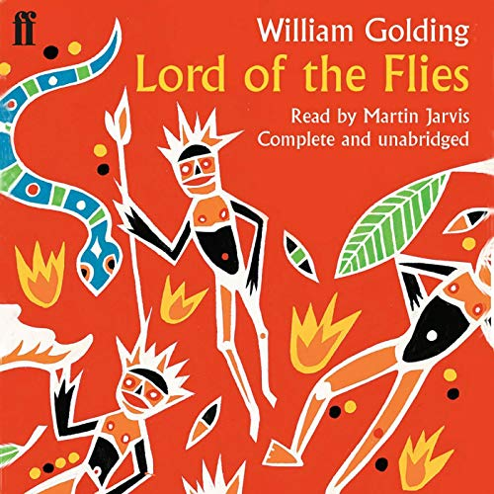

**Key Terms for this unit:**

Tone

Personification

Literary techniques

Civilisation

Savagery

**Reading Recommendations:**

**The Hunger Games** by Suzanne Collins

**Animal Farm** by George Orwell

**Treasure Island** by Robert Louis Stevenson

**The Maze Runner** by James Dashner

**The Giver** by Lois Lowry

**Library Lessons and Accelerated Reader.**

Students have a reading lesson in the library once a fortnight with their English teacher. This is an opportunity to check they are reading the correct books, find out if there are any problems and encourage them to try something new. Students should complete a quiz on every book they read.

They can also quiz from home. They can access Accelerated Reader via the school website.

**Assessment for this unit:**

Creative writing. They will use the skills they have been taught reading the text to create their own piece of writing. Skills: accurate writing, using features of descriptive writing, and advanced vocabulary

**What will we be looking at:**

Civilisation and Savagery

Tone and Personification

Sensory Language

Power and Control

Author’s purpose

Creative Description

Sentence Variety

**D.E.A.R**

Students will stop what they are doing once a day and read for 20 minutes in lessons.

They must have a reading book with them every day.